**Computer Fundamentals**

|  |  |  |
| --- | --- | --- |
| **Parameter** | **High-Level Language** | **Low-Level Language** |
| Basic | These are programmer-friendly languages that are manageable, easy to understand, debug, and widely used in today’s times. | These are machine-friendly languages that are very difficult to understand by human beings but easy to interpret by machines. |
| Ease of Execution | These are very easy to execute. | These are very difficult to execute. |
| Process of Translation | High-level languages require the use of a compiler or an interpreter for their translation into the machine code. | Low-level language requires an assembler for directly translating the instructions of the machine language. |
| Efficiency of Memory | These languages have a very low memory efficiency. It means that they consume more memory than any low-level language. | These languages have a very high memory efficiency. It means that they consume less energy as compared to any high-level language. |
| Portability | These are portable from any one device to another. | A user cannot port these from one device to another. |
| Comprehensibility | High-level languages are human-friendly. They are, thus, very easy to understand and learn by any programmer. | Low-level languages are machine-friendly. They are, thus, very difficult to understand and learn by any human. |
| Dependency on Machines | High-level languages do not depend on machines. | Low-level languages are machine-dependent and thus very difficult to understand by a normal user. |
| Debugging | It is very easy to debug these languages. | A programmer cannot easily debug these languages. |
| Maintenance | High-level languages have a simple and comprehensive maintenance technique. | It is quite complex to maintain any low-level language. |
| Usage | High-level languages are very common and widely used for programming in today’s times. | Low-level languages are not very common nowadays for programming. |
| Speed of Execution | High-level languages take more time for execution as compared to low-level languages because these require a translation program. | The translation speed of low-level languages is very high. |
| Abstraction | High-level languages allow a higher abstraction. | Low-level languages allow very little abstraction or no abstraction at all. |
| Need of Hardware | One does not require a knowledge of hardware for writing programs. | Having knowledge of hardware is a prerequisite to writing programs. |
| Facilities Provided | High-level languages do not provide various facilities at the hardware level. | Low-level languages are very close to the hardware. They help in writing various programs at the hardware level. |
| Ease of Modification | The process of modifying programs is very difficult with high-level programs. It is because every single statement in it may execute a bunch of instructions. | The process of modifying programs is very easy in low-level programs. Here, it can directly map the statements to the processor instructions. |
| Examples | Some examples of high-level languages include Perl, BASIC, COBOL, Pascal, Ruby, etc. | Some examples of low-level languages include the Machine code and Assembly language. |

**1883: The Journey starts from here…!!**

* In the early days, Charles Babbage had made the device, but he was confused about how to give instructions to the machine, and then Ada Lovelace wrote the instructions for the analytical engine.
* The device was made by Charles Babbage and the code was written by Ada Lovelace for computing Bernoulli’s number.
* First time in history that the capability of computer devices was judged.

**1949: Assembly Language**

* It is a type of low-level language.
* It mainly consists of instructions (kind of symbols) that only machines could understand.
* In today’s time also assembly language is used in real-time programs such as simulation flight navigation systems and medical equipment eg – Fly-by-wire (FBW) systems.
* It is also used to create computer viruses.

**1952: Autocode**

* Developed by Alick Glennie.
* The first compiled computer programming language.
* COBOL and FORTRAN are the languages referred to as Autocode.

**1957: FORTRAN**

* Developers are John Backus and IBM.
* It was designed for numeric computation and scientific computing.
* Software for NASA probes voyager-1 (space probe) and voyager-2 (space probe) was originally written in FORTRAN 5.

**1958: ALGOL**

* ALGOL stands for **ALGO**rithmic **L**anguage.
* The initial phase of the most popular programming languages of C, C++, and JAVA.
* It was also the first language implementing the nested function and has a simple syntax than FORTRAN.
* The first programming language to have a code block like “begin” that indicates that your program has started and “end” means you have ended your code.

**1959: COBOL**

* It stands for**CO**mmon **B**usiness-**O**riented **L**anguage.
* In 1997, 80% of the world’s business ran on Cobol.
* The US internal revenue service scrambled its path to COBOL-based IMF (individual master file) in order to pay the tens of millions of payments mandated by the coronavirus aid, relief, and economic security.

**1964: BASIC**

* It stands for beginners All-purpose symbolic instruction code.
* In 1991 Microsoft released Visual Basic, an updated version of Basic
* The first microcomputer version of Basic was co-written by Bill Gates, Paul Allen, and Monte Davidoff for their newly-formed company, Microsoft.

**1972: C**

* It is a general-purpose, procedural programming language and the most popular programming language till now.
* All the code that was previously written in assembly language gets replaced by the C language like operating system, kernel, and many other applications.
* It can be used in implementing an operating system, embedded system, and also on the website using the Common Gateway Interface (CGI).
* C is the mother of almost all higher-level programming languages like C#, D, Go, Java, JavaScript, Limbo, LPC, Perl, PHP, Python, and Unix’s C shell.

Some other programming languages that are popular among programmers are listed below.

| **YEAR OF RELEASE** | **PROGRAMMING LANGUAGES** | **FACTS** |
| --- | --- | --- |
| **1972** | SQL | SQL was developed at IBM by Donald D. Chamberlin and Raymond F. Boyce. The earlier name was SEQUEL (Structured English Query Language). |
| **1978** | MATLAB | It stands for MATrix LABoratory. It is used for matrix manipulation, implementation of an algorithm, and creation of a user interface. |
| **1983** | Objective-C, C++ | C was Developed by Dennis Ritchie (1972)  C++ was Developed by Bjarne Stroustrup (1983)  C++ is the fastest high-level programming language.  Earlier, Apple Inc uses Objective-C to make applications. |
| **1990** | Haskell | It is a purely functional programming language. |
| **1991** | Python | Developed by Guido van Rossum  The language is very easy to understand.  Famous language among data scientists and analysts. |
| **1995** | JAVA, PHP, JavaScript | JAVA is everywhere. JAVA is the platform-independent language.  PHP is a scripting language mainly used in web programming for connecting databases.  JavaScript enables interactive web pages. JS is the most popular programming language. JS is famous for building a web application. It makes our page interactive. |
| **2000** | C# | C#(C-sharp) is mainly used for making games. Unity engine uses C# for making amazing games for all platforms |
| **2009** | GO | GO language is developed in Google by Robert Griesemer, Rob Pike, and Ken Thompson. |
| **2011** | Kotlin | Kotlin is developed by JetBrains. It is used for making an android application. |
| **2014** | Swift | Swift language is developed by Apple Inc. It is a general-purpose programming language. |

Memory is used for storing Data and Instruction,

SM is used for Storing Data.

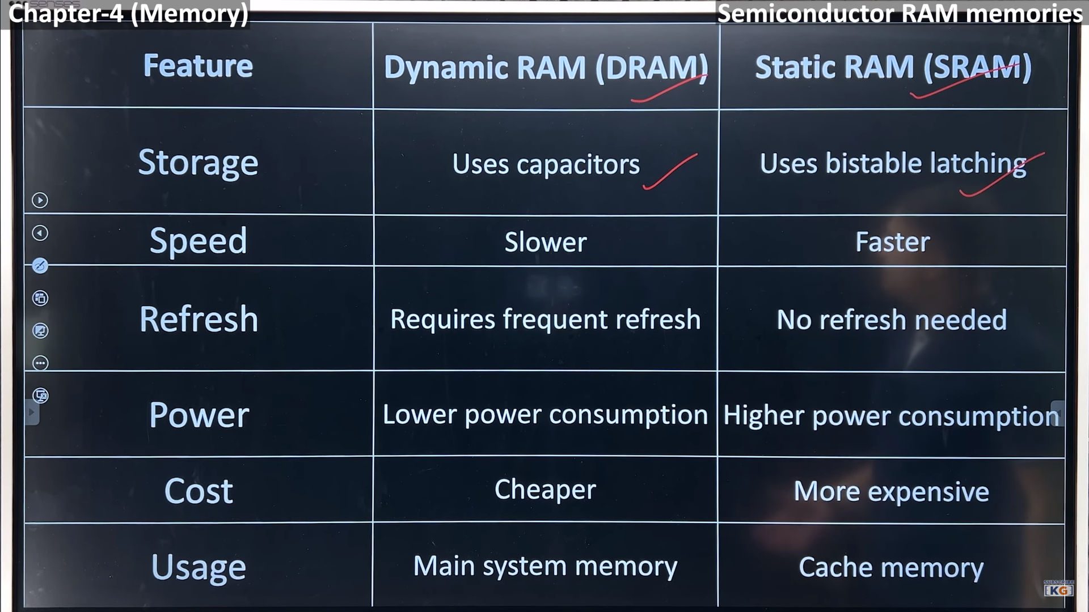

Bistable Latching means FlipFlop.

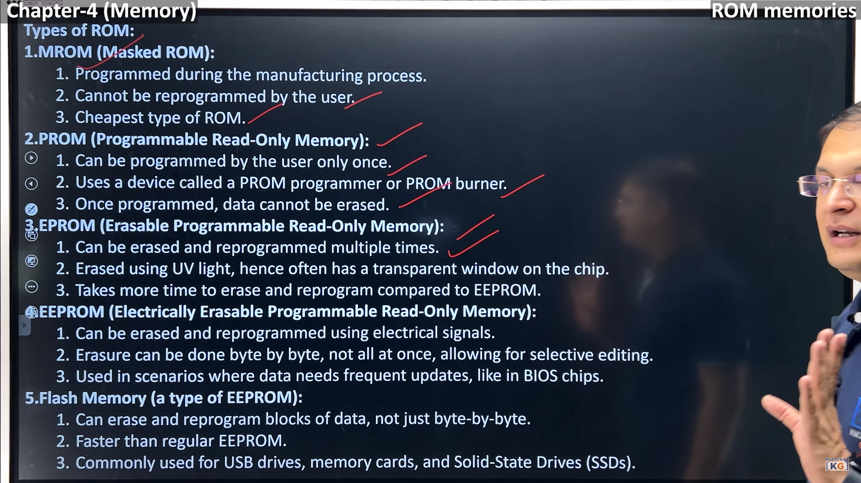

**Algorithms and Flowchart** –

**Flowchart –** is a Graphical or pictorial Representation of step by step solution of the problem.

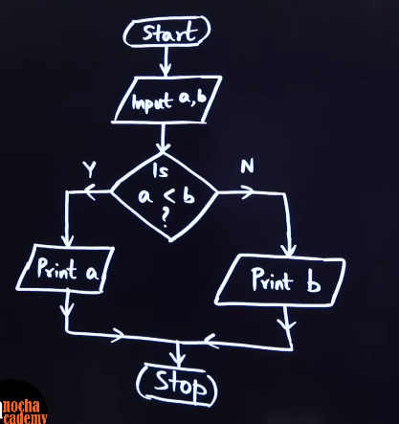 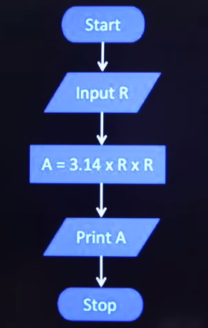 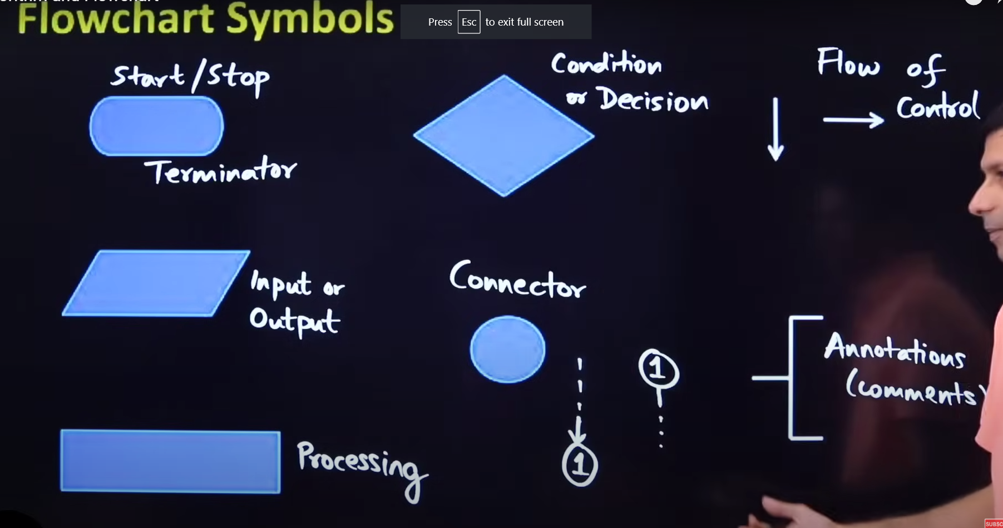

Connector is used if the page ends and we have to start from the next page.

If a= b Then either will be printed.

**Algorithms -** are a set of steps to solve a problem. (Written is simple form like in English)

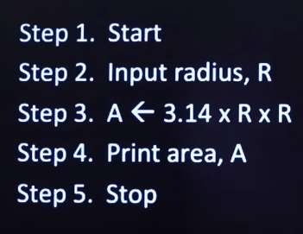You can verify the algo with a dry run or a trace Table.

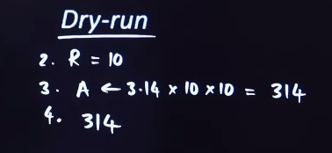 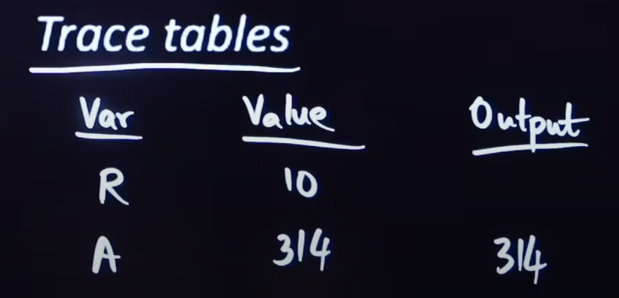

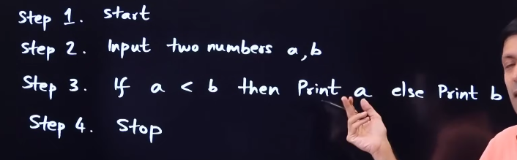

**Pseudo Code –** is an informal way of describing the steps of program’s solution without using a strict programming language syntax.

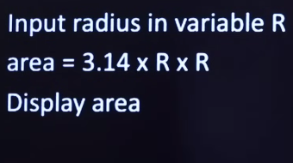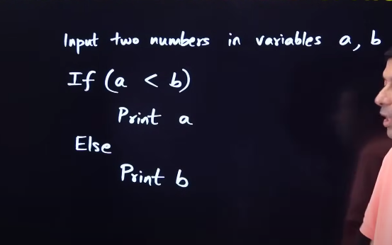

Close to the real code, it’s informal so Focus on the logic.

Example -

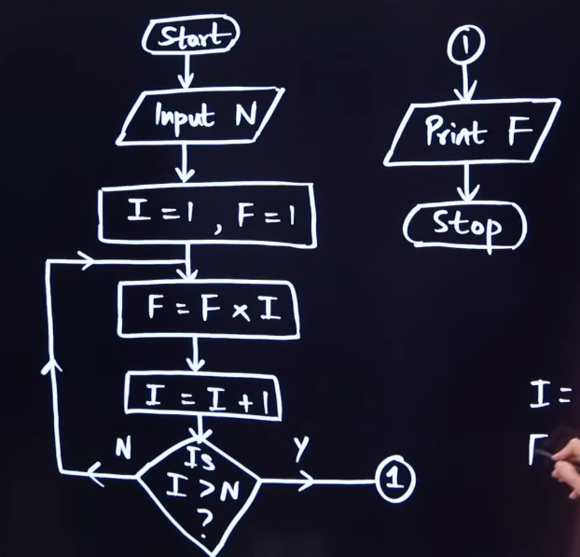 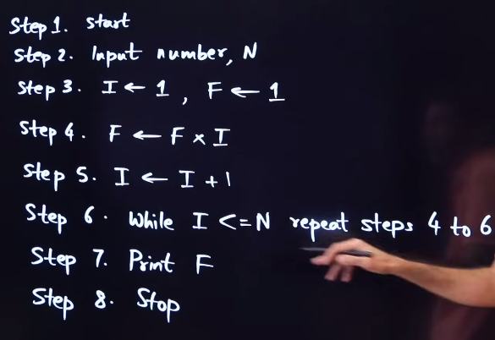

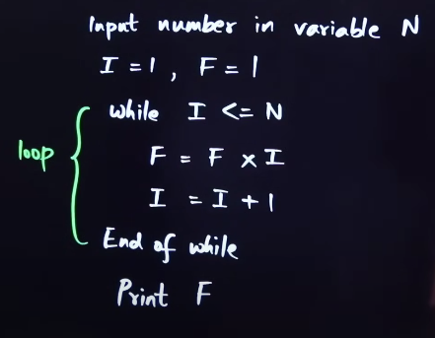

**Memory** –

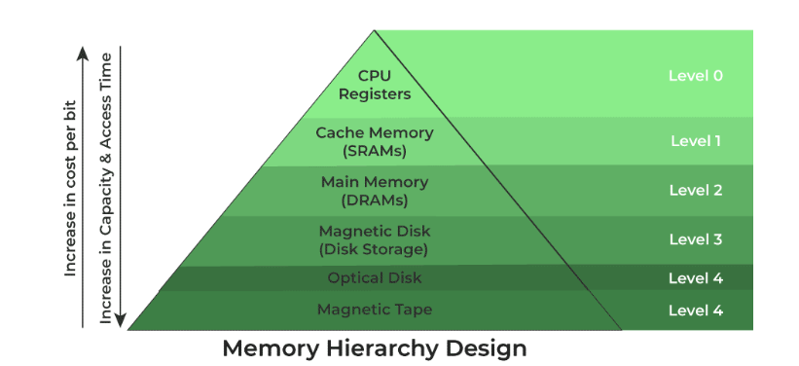

[Registers](https://www.geeksforgeeks.org/different-classes-of-cpu-registers/) are small, high-speed memory units located in the CPU. They are used to store the most frequently used data and instructions. Registers have the fastest access time and the smallest storage capacity, typically ranging from 16 to 64 bits.

* **Accumulator:**   
  This is the most frequently used register used to store data taken from memory. It is in different numbers in different microprocessors.
* **Memory Address Registers (MAR):**   
  It holds the address of the location to be accessed from memory. MAR and MDR (Memory Data Register) together facilitate the communication of the CPU and the main memory.
* **Memory Data Registers (MDR):**   
  It contains data to be written into or to be read out from the addressed location.
* **General Purpose Registers:**   
  These are numbered as R0, R1, R2….Rn-1, and used to store temporary data during any ongoing operation. Its content can be accessed by assembly programming. Modern CPU architectures tends to use more GPR so that register-to-register addressing can be used more, which is comparatively faster than other [addressing modes](https://www.geeksforgeeks.org/addressing-modes/).
* **Program Counter (PC):**   
  Program Counter (PC) is used to keep the track of execution of the program. It contains the memory address of the next instruction to be fetched. PC points to the address of the next instruction to be fetched from the main memory when the previous instruction has been successfully completed. Program Counter (PC) also functions to count the number of instructions. The incrementation of PC depends on the type of architecture being used. If we are using 32-bit architecture, the PC gets incremented by 4 every time to fetch the next instruction.
* **Instruction Register (IR):**   
  The IR holds the instruction which is just about to be executed. The instruction from PC is fetched and stored in IR. As soon as the instruction in placed in IR, the CPU starts executing the instruction and the PC points to the next instruction to be executed.
* **Condition code register (CCR ) :**  
  Condition code registers contain different flags that indicate the status of any operation for instance lets suppose an operation caused creation of a negative result or zero, then these flags are set high accordingly and the flags are

1. Carry C: Set to 1 if an add operation produces a carry or a subtract operation produces a borrow; otherwise cleared to 0.
2. Overflow V: Useful only during operations on signed integers.
3. Zero Z: Set to 1 if the result is 0, otherwise cleared to 0.
4. Negate N: Meaningful only in signed number operations. Set to 1 if a negative result is produced.
5. Extend X: Functions as a carry for multiple precision arithmetic operations. All These are decided by ALU.

[Cache memory](https://www.geeksforgeeks.org/cache-memory-in-computer-organization/) is a small, fast memory unit located close to the CPU. It stores frequently used data and instructions that have been recently accessed from the main memory. Cache memory is designed to minimize the time it takes to access data by providing the CPU with quick access to frequently used data.

**RAM (Random Access Memory):** It is a volatile memory. Volatile memory stores information based on the power supply. If the power supply fails/ interrupted/stopped, all the data and information on this memory will be lost. [RAM](https://www.geeksforgeeks.org/random-access-memory-ram/) is used for booting up or start the computer. It temporarily stores [programs/data](https://www.geeksforgeeks.org/difference-between-program-and-data/) which has to be executed by the [processor](https://www.geeksforgeeks.org/role-of-processor-in-a-pc/). RAM is of two types:

* **Static RAM:** [Static RAM](https://www.geeksforgeeks.org/difference-between-sram-and-dram/) stores the binary information in flip flops and information remains valid until power is supplied. It has a faster access time and is used in implementing cache memory. (Comp k wath ko 10 saal baad bhi on kroge toh sahi time dikhayega, till the time u don’t change it).
* **Dynamic RAM:** It stores the binary information as a charge on the capacitor and transistors. It requires refreshing circuitry to maintain the charge on the capacitors after a few milliseconds. It contains more memory cells per unit area as compared to SRAM. This memory is slower than S RAM. (Live match chlta hai toh frequently Refresh hona pdta hai).

There are mainly 5 types of DRAM.

* **Asynchronous DRAM (ADRAM):** The timing of the memory device is controlled asynchronously. A specialized memory controller circuit generates the necessary control signals to control the timing. The CPU must take into account the delay in the response of the memory.
* **Synchronous DRAM (SDRAM):**These RAM chips’ access speed is directly synchronized with the CPU’s clock. For this, the memory chips remain ready for operation when the CPU expects them to be ready. These memories operate at the CPU-memory bus without imposing wait states. SDRAM is commercially available as modules incorporating multiple SDRAM chips and forming the required capacity for the modules.
* **Double-Data-Rate SDRAM (DDR SDRAM):**This faster version of SDRAM performs its operations on both edges of the clock signal; whereas a standard SDRAM performs its operations on the rising edge of the clock signal. Since they transfer data on both edges of the clock, the data transfer rate is doubled. To access the data at a high rate, the memory cells are organized into two groups. Each group is accessed separately.
* **Rambus DRAM (RDRAM):**The RDRAM provides a very high data transfer rate over a narrow CPU-memory bus. It uses various speedup mechanisms, like synchronous memory interface, caching inside the DRAM chips and very fast signal timing. The Rambus data bus width is 8 or 9 bits.
* **Cache DRAM (CDRAM):**This memory is a special type of DRAM memory with an on-chip cache memory (SRAM) that acts as a high-speed buffer for the main DRAM.

**ROM (Read Only Memory):**It is a non-volatile memory. Non-volatile memory stores information even when there is a power supply failed/ interrupted/stopped. [ROM](https://www.geeksforgeeks.org/read-only-memory-rom/) is used to store information that is used to operate the system. As its name refers to read-only memory, we can only read the programs and data that is stored on it. It contains some electronic fuses that can be programmed for a piece of specific information. The information stored in the ROM in binary format. It is also known as permanent memory. ROM is of four types:

* + **MROM(Masked ROM):**Hard-wired devices with a pre-programmed collection of data or instructions were the first ROMs. Masked ROMs are a type of low-cost ROM that works in this way.
  + **PROM (Programmable Read Only Memory):** This read-only memory is modifiable once by the user. The user purchases a blank PROM and uses a [PROM](https://www.geeksforgeeks.org/prom-full-form/) program to put the required contents into the PROM. Its content can’t be erased once written.
  + **EPROM (Erasable Programmable Read Only Memory):** [EPROM](https://www.geeksforgeeks.org/eprom-full-form/) is an extension to PROM where you can erase the content of ROM by exposing it to Ultraviolet rays for nearly 40 minutes.
  + **EEPROM (Electrically Erasable Programmable Read Only Memory):**Here the written contents can be erased electrically. You can delete and reprogramme [EEPROM](https://www.geeksforgeeks.org/eeprom-full-form/) up to 10,000 times. Erasing and programming take very little time, i.e., nearly  4 -10 ms(milliseconds). Any area in an EEPROM can be wiped and programmed selectively.
* Flash memory is secondary memory and so it is not volatile which means it persists the data even if there is not an electrical supply provided. This flash memory works on the principle of EEPROM. EEPROM stands for Electrical Erasable Programmable Read-Only Memory. ROM operation can only one time write and many times read and we can’t erase it. But Flash Memory can be erased multiple times and update the data or program integrated into it.

## **Types of Flash Memory**

* **NAND flash memory:**NAND flash memory has high memory cell density so it has high capacity to store the data. Memory cards, [USB](https://www.geeksforgeeks.org/universal-serial-bus-usb-in-computer-network/) drives, and [SSD (Solid State Drive)](https://www.geeksforgeeks.org/introduction-to-solid-state-drive-ssd/) use this type of flash memory which uses low power to store data, it has low power consumption. NAND flash memory cell is made up of two gates.
  + Control gate
  + Floating gate
* **NOR flash memory:**NOR Flash Memory is made up of FGMOS or FGMOSFETs (Floating Gate Metal Oxide Field Effect Transistors). FGMOS is an electronic component in NOR flash memory that can contain 0 or 1. So we can say that the memory cell in the NOR flash memory is FGMOS. Cells of NOR flash memory are attached in a parallel manner so reading speed of this type of flash memory is faster compared to other.
* **3D flash memory:**It is a newer type of flash memory. It has a memory cell density greater than NAND flash memory also. It is used in high capacity SSDs.

### **3. Cache Memory**

It is a type of high-speed semiconductor memory that can help the CPU run faster. Between the CPU and the main memory, it serves as a buffer. It is used to store the data and programs that the CPU uses the most frequently. SRAM memories are used to build [Cache Memory](https://www.geeksforgeeks.org/cache-memory/). The most important use of cache memory is that it is used to reduce the average time to access data from the main memory.

We can improve Cache performance using higher cache block size, and higher associativity, reduce miss rate, reduce miss penalty, and reduce the time to hit in the cache.

Types –

* Direct Mapping
* Associative Mapping
* Set-Associative Mapping

### 4. Secondary Storage

It is also known as auxiliary memory and [backup](https://www.geeksforgeeks.org/backup-and-restore/)memory. It is a non-volatile memory and used to store a large amount of [data or information](https://www.geeksforgeeks.org/difference-between-information-and-data/). The data or information stored in secondary memory is permanent, and it is slower than primary memory. A [CPU](https://www.geeksforgeeks.org/central-processing-unit-cpu/) cannot access secondary memory directly. The data/information from the auxiliary memory is first transferred to the main memory, and then the CPU can access it.

### **Control Unit**

* Controlling of data and transfer of data and instructions is done by the control unit among other parts of the computer.
* The control unit is responsible for managing all the units of the computer.
* The main task of the control unit is to obtain the instructions or data which is input from the memory unit, interprets them, and then directs the operation of the computer according to that.
* The control unit is responsible for communication with Input and output devices for the transfer of data or results from memory.
* The control unit is not responsible for the processing of data or storing data.

### **ALU (Arithmetic Logic Unit)**

**Arithmetic Section:**By arithmetic operations, we mean operations like addition, subtraction, multiplication, and division, and all these operation and functions are performed by ALU. Also, all the complex operations are done by making repetitive use of the mentioned operations by ALU.

**Logic Section:** By Logical operations, we mean operations or functions like selecting, comparing, matching, and merging the data, and all these are performed by ALU.

**Computer Architecture**

Von Neuman’s Architecture (Main Memory Program)– Main Memory me 2 cheezein store hoti hai – Data(int a=10) and Programs(add,sub,c=a+b).

Harward Architecture me dono alag alag memory m store krte the.

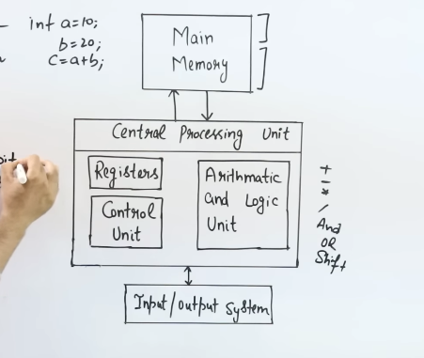

Various General Purpose Registers – Registers are sequence of bits or flipflops, Memory representational unit is word. Isliye wo word addressable hai, Byte addressable bhi hota hai but we know the size of 1byte=8bits. But aaj kal k computer me more then 1byte bhi isliye word addressable hai.

4096- kitne words aaskte

16 – ek word ka size kya hai toh 16bits or 2 bytes.

4096 =212

Address Register – Memory se Address uthane k kaam aata hai (size hoga iska 12 (0-11) as per out example). Address register address deta hai memory ko ki is location se uthana hai instruction ko. Memory jayegi us location m and dat ko fetch kregi.

Data register – Data is stored in this register = 16bit (0-15).

Accumulator – Intermediate data ko store krna hai, Memoryse utha k ALU ko dena hai data toh temporary store kr skte data ko. = 16bit.

Program Counter – Next instruction jisko execute krna hai wo kidhr pdi hui hai uska address store krta hai. = 12bit (0-11)

Instruction Reg – Instruction is stored here. = 16bit

I – (Direct addressing) 0 hai agr ism toh directly jo operand m address hai udhr jaate hi mil jayega data jispr operation peraform krna hai.

(indirect addressing) 1 hai agr toh uss address m bhi dusre jagah ka address stored hai udhr milega data.

I is =1bit

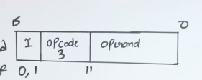Opcode – kya operation perform krna hai = 3bit

Operand – address uska jispr ye operation perform krna hai. = 12bit(stores address)

Jaise hi uss address m jaate hi data milta hai us data ko memory s utha k accumulator ko de do.

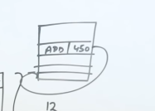

Temporary Reg – Data temporary store krte hai. = 16bits

Input Reg – input device se data uthana hai and Input reg m rkhna hai and ALU ko pass kr dena hai. (8bits). Memory se lena den ani hai iska kuch.

Output Reg – ALU n data diya toh ab kis ouput device ko dena hai ye value, we use output Reg. =8bits.

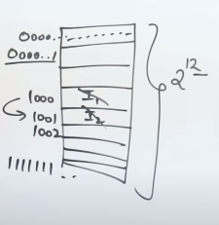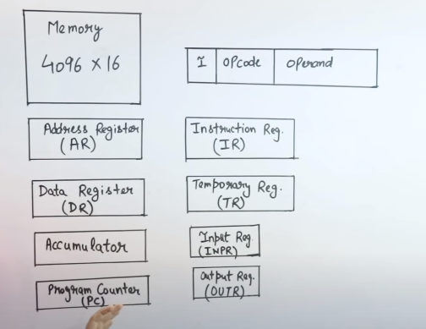

Address Bus - Processer hai jo address generate krta hai, So agr Memory se ko address uthana hai ya Input lena hai input device se ya fir output dena hai kisi output device ko toh Address bus ka use krta hai CPU.

16bit ka hota hai mtlb =216 slots jote and harr ek ka address jo hai wo represent krte with 16bit address(000000000000000)

Unidirectional hai.

Data bus – Data Travel krne k liye ise use krte. Input device se koi data gya toh wo data bus k through jaa k Processor m chla jata aur register k andar store hota. Data bus bidirectional hai. And iska size depend krta hai WORD k size me, jitna data ka size hoga utna hi iska size hoga. Agr data ka size chota hai toh LSB m value hogi in the form of 0s and 1s and MSB will be all 0

Control Bus – Used to send Control and Timing Signals. Kaun sa instruction kb load hoga wo ispr depend krta hai. Desired output milta hai agr sahi sequence m execute hota hai toh. (Load krni hai value Reg me toh use LD, to increment use INR, to clear use CLR, Memory me agar kuch read ya write krna hai tb).

Timing Signals mtlb kis time me, clock p ulse generate hota hai.

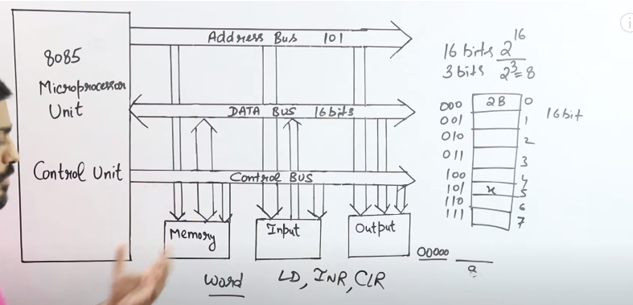

Common Buses are used to connect registers.

Buses are made up of multiplexers.  
No. of Mux = No. of bits in reg.

No. of I/P in MUX = No. of reg.

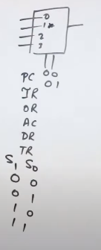

Select line values = 00,01,10,11

Agr 00 dega toh MUX ki first line uthayega.

Harr MUX ka first line select hoga A0,A1,A2,A3. Then Reg A ka data bus m load hoga for further process. Ab wahan se ALU jayega ya Memory jayega ya kisi aur Reg m jaa skta hai.

Reg B m jaayega tb Reg A ka data connect hoga baaki saare Reg se bhi but Control unit Load=1 kr dega for Reg B only.

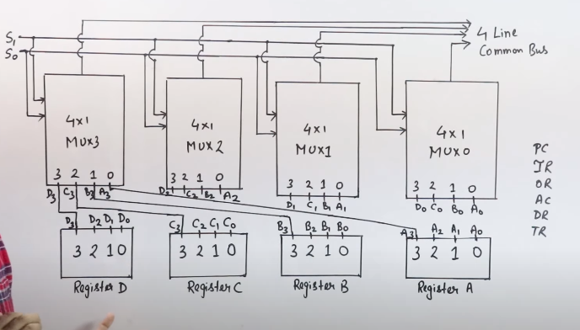

How Basic Computer Works.

7 (8th one is reserved for some other purpose if required) input deni hai reg ko toh select lines honi chahiye 3

No. of input = 2^n (n= no. of select lines)

Memory unit me data and instructions stored hain.

Sare Reg connected hai Common bus k saath except for IR and Or, IR leta hai input devicd se input and ALU ko pass krta hai idhr ek simple sa Adder and Logic le rahe hai hum instead of ALU and wo accumulator se connected hai and “E” is for storing carry if generate hota hai toh, OR is connected to bus jiss se result aata hai usm and then ye output devices ko send krta hai.

4096 or 2^12 slots ai, harr ek slot ka size 16 hai and usm 12 digit values bhari hui hain and MSB shuru ki 4 jo hai wo 0000 hai.

AR k pass address pda hai jisko uthana hai MMORY UNIT se and DR(DATA REG) m dalana hai toh PC k andar w address stored hai jisko execute krna hai.

Toh PC is at value 2 in MUX so select lines 010 dega and MUX me PC select hoga and Bus m load hoga. And CU- AR ki Load value 1 kr dega. AR is connected to MU and MU has Decoders jo ki us 12bits ko decode kr k, exact location m jaa kr Data read krenge agr Read instruction diya hoga user ne toh then MUX ki value hogi 111 coz MU is at 7th position and uski value BUS m ajayegi. And ab wo data 16 bit k DR m agya. Wo value ab ALU m jayegi and wo perform krega and Accumulator m save hoga then as AC=4 thn 100 krte hi bus m load hogi value and wo desired Output deivce ko chla jayega(OR ki Load =1 hogi tb).

LD,INR,CLR are all connected to CLOCK.

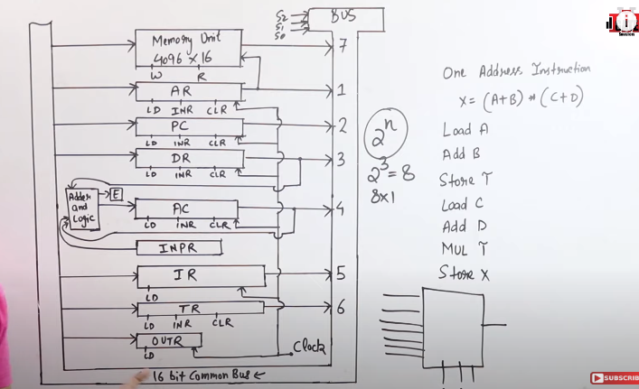

Load A hua toh PC ne AR ko address diya jo ki AR ne Memory Unit ko bataya and 111(7) hua select lines and Bus m aagya value wahan s DR m gya then ALU k through AC me store hua, Same B k saath hua lekin Alu k through A k saath add ho k AC m store hua then, is value ko abhi TR m store kro and C and D k saath bhi same kro and jb hojayeg tb TR ki value ko wps Alu k through AC ki current value se Multiply kr do and AC m hi store kro and OR ko de do.

Types of Instruction in General Purpose Computer –

* 1. Data Transfer Instruction – R1 to R2 ya R to MM data transfer krna hai toh wo instructions. Load krna hai basically.
  2. Data Manipulation Instructions – Data Change krna hai tb. Ex – Arithmetic, Logical, Shift or conversion.
  3. Program Control Instruction – if, loop, for, while type of conditions ko execute krne k liye use hota hai.

Mov R1 R2 (R2 ki value R1 m daal do)

Mov R1 500

Mov R1 X (X address p jo pda hai value wo daal do Reg me.)

(Diff Addressing Modes k hisaab se likhte hai)

LD – to load AC with data from MM

STA (Store) – Reg se Data bhejna hai MM me.

XCHG (Exchange) – XCHG R1 R2

In (Input) – Peripheral device se MM m dalna hai.

Output – Opposite

Push and Pop – When MM is used as a stack, Push to fill MM and Pop to take out the data, LIFO use krta hai. Ya Regs ko us sequence m rkhta hai like STACK.

Set – Reg me 1 lana hai toh.

Clear – Reg me 0 lana hai toh.

Arithmetic Instructions – Data Manipulation k liye use hote hai.

Add –

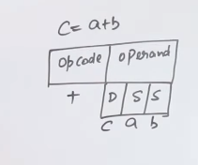 D = Destination Address, S = Source Address

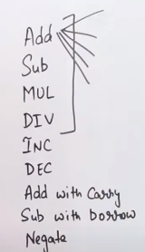 Negata = 5 to -5

Logical Instructions –

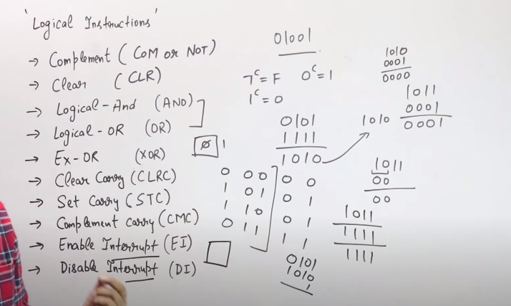

Clear carry – flag bit me 0 hoga ya 1 hoga toh, clear krna hua us flag bit ko toh use krte.

Set carry – 0 ko 1 krna hai. (2’s compliment krte waqt 1 jo add krte wo idhr se hi aata).

Compliment carry – flag bit 1 hai toh usko 0 krna hai (NOT Operator) ya viceversa.

Interrupts – CPU run kr ra file and beech m usko I/O kaam k liye jana hai toh flag bit ko 1 krne se interrupt aata hain tb CPU pehle wo kaam krta hai and then continue krta hai.

Shift Instructions – Reg k andar agr data load ho rah ai toh bits ko left ya right ki taraf move krna hota hai.

* + 1. Logical Shift Left - 0 1 0 1 0 = 1 0 1 0 0
    2. Logical shift right – 0 1 0 1 0 = 0 0 1 0 1
    3. Arithmetic SR – 1 0 1 0 1 = 1 1 0 1 0 (First wala digit (sign) same hoga).
    4. Arithmetic SL – same as LSL
    5. Rotate Right – 1 0 1 0 1 = 1 1 0 1 0 (Last Bit ghoom k saamne and baaki sb shift Right).
    6. Rotate Left – 1 0 1 0 1 = 0 1 0 1 1 (Opp of RR)
    7. Rotate right through carry – 1 1 0 1 0 0 = 0 1 1 0 1 0
    8. Rotate Left through carry - 1 1 0 1 0 0 = 1 0 1 0 0 1

|  |  |  |  |  |
| --- | --- | --- | --- | --- |
| Addressing Mode | OP Code | Type of shift  (Left or Right) | Count | Operand |

Program Control Instructions/Transfer of Control Instructions –

Program Counter ko hum jb Implicit Mode me execute krte hai tb 1 by 1 in sequence Execute hote hai instructions. Ab instructions ki sequence ko maintain krne k liye use hota hai PCI.

Types – Branch – Unconditional and Conditional,

Normally hum sequentially execute krte hai, But kbhi jump instruction ya branch instruction ya skip use krte hai jb humko sequence m ni rna hota hai.

**Unconditional**

I1 execute hua toh PC point kr ra I2 ko

Then I2 execute hua toh I3 ko

Lekin I3 p Skp(skip) likha hua hai toh ab I4 store krega PC.

I4 execute hua hai ttb I5 point krega PC and

I5 m likha hai Call 3000 tb PC point krega siddha 3000 address ko. I5 execute ni hoga. 300 execute hoga then Return hoga

(Ex - Call, Return, Skip, Branch, Jump).

**Conditional**

BE R1 R2 2000

BE means Branch equal, if R1 and R2 ki value same hai toh Jump kro 2000 p.

Agr ni hai toh Next instruction ko point krega PC.

BNZ R1 2000

Branch if not zero

R1=0 hai toh kuch ni hoga next instruction p jayega.

Instruction Format –

MM me hota hai data and Instructions stored, toh IR ki madad se jism Mode, Op Code and Operand hai, ALU m data aata hai and process hota hai and Ouput milta hai.

Mode – batata hai ki direct ya indirect addressing hai.

Types of CPU organisations –

* + 1. **Single Accumulator org** – Single operand hota hai ism. **Single address instructions.**

LD A = A ki value load hogyi AC me

ADD B = AC me A+B store hoga.

Store X = X me store hoga AC ka value

Single operand use kr re bs. Toh number of Operations zyada hojate hai. Cost lekin least hoga. 

IR

* + 1. **General Acc Org** – Speed zyada chahiye tb ye use krte kyunki Reg zyada hote. **2-3 address Instructions.**

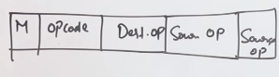Add R, A, B i.e. R=A+B

Add R2, C, D i.e. R2=C+D

MUL X, R, R2  
Instruction ki length badi toh IR ka size badhega.

* + 1. **Register Stack Organisation** – **Zero address instructions**, using different REG as Stack(LIFO).

Fihaal 64 word(0-63) REG use kr re harr reg ek word store krta. 63 is 111111 so they will store 5 bits.

Stack Pointer(or top of the stack) point krta hai jis location p value push ya pop krna hai.

Full = 0 means full nahi hai

Empty = 1 means khaali hai.

Push and pop normally hota hai

1st Reg s bhrna shuru hota hai 0th khaali rehta hai shuru m

Agr 63rd place m hai and Push krta hai wps se toh 64 place toh hai ni and 64 =1000000 and 6bit hi dekhta ye so it is 000000 which is the 0th place so us memory location m jaati value and check hota aage ka operation and Full =1 hojata which means full hogya hai and empty =0 hojata which means empty ni hai.

**We use Zero address instructions with RSO which means**

Push A

Push B

ADD (We don’t add an operand with ADD. Address size will be small)

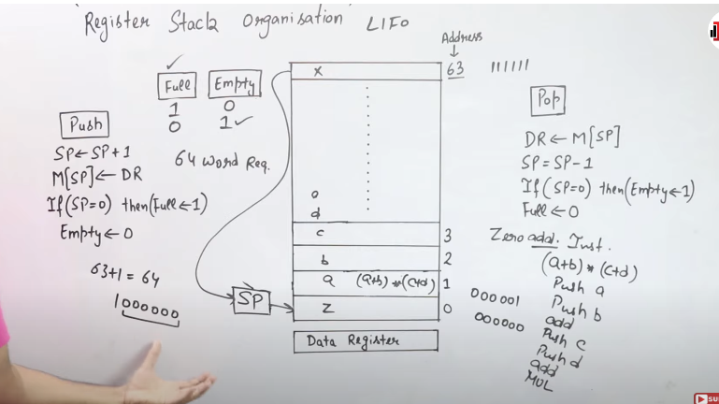

Memory Stack Org – We can Use Reg as Stack or Main Memory as Stack.

Few space is reserved for Instructions(Printf, scanf), Few for Operands others are used as stack.

Instruction pehle fetch hoti hai then decode hoti hai then Execute hoti hai.

Differnce ye hai ki Reg Stack Org me number of Stacks zyada hai tohi ski wajah se cost zyada hoga uska.

Sp point kr ra top value ko hum usko least value ko bhi kr skte point but idhr mann tha isliye kr re, toh agr top value ko krega point toh decrement kr re Address ko during Push function. (4000 se 3999 ja ra ulta bhi kr skrte tb increment krna hoga bs 3999-4000).

Lowe limit Reg hai to tell the lower limit and Upper limit Reg to tell the Upper limit, they tell whether the Stack is full or empty.

Also has Zero address instructions – No operand needed sometimes

Push A Push B Add(add has no operand) wo AC m hi store kr lega values.

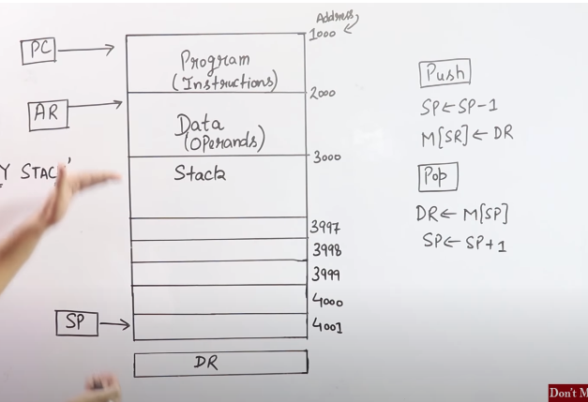

**Addressing Modes**– The term addressing modes refers to the way in which the operand of an instruction is specified. The addressing mode specifies a rule for interpreting or modifying the address field of the instruction before the operand is actually executed.

* 1. **Implied Mode** – Operand is specified implicitly in the definition of instruction.

Used for Zero address (ADD – Add kr do last two values ko) and one address instructions (INC A, CLC, CL A).

Alag se memory dene ki zaroorat ni hai, Operand k andar hi pta chlega ki kis data p ya kahan kaam krna hai. Instruction ka size chota hoga.

* 1. **Immediate Mode** – Data Operand m directly diya hoga as constant.No Computation require.

(Add R1, #3 = R1<-R1+3).

Int a =10 kiye tb a ki value de ni skte kyunki baad m chnge ho skti hai value. Constant ki value Operand ki Size k less than equal hona chahiye.

* 1. **Register Mode** – Operand is present in the Register. Register ka number pda hua hai ism, to uss reg m jaao udhr value milegi.

Effective address ka mtlb hota hai ki directly operand m ni hai data Reg m jaao udhr se le k aao. Operand ki size = Reg ka size (No. of reg =16, 2^4 so operand size is 4 bits). Regs ki wajah s Speed bohot zyada hogi.

* 1. Register Indirect Mode – Operand ki jagah m Address hai Reg ka uss Reg m Address hai ab Memory ka and uss Memory Location m hai Data.

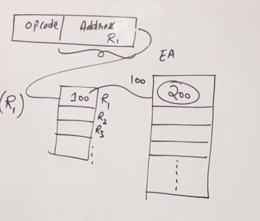Effective Address =

LD R1 (AC m load kro R1 ki value)

AC<= M[R1] (R1 m memory address hai and udhr hai data stored).

* 1. **Auto Increment or Auto decrement Addressing Mode –** Special case of Register Indirect Mode. Agr Table of Data hai toh starting address do bs then increment ya decrement kr k aage ka data fetch kr skta hai wo.

Ld (R1)+

Ac<=M[R1]

R1 m 200 address tha MM ka

AC me gya, Wo value then increment hua then ab 201 value m hai ab wo value jayegi AC k andar and so on.

* 1. Direct Addressing Mode (Absolute AM) – Actual address pda hua hai Operand(Address bit) m MM ka. Used to access Variables.

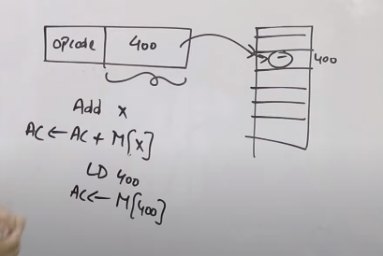Adv- No computation required.

Dis - Address ki size Operand ki size se less than equal honi chahiye.

* 1. Indirect Addressing Mode – Used to implement pointers and passing Parameters. 2 memory access required.

Address bit me MM ka ek address hai ab uss MM address me ek aur address hain ad us address m operand ya data hai.   
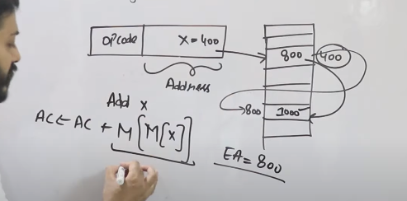

Effective address is 800 idhr.

Adv – Pointers ki facility provide krta hai and Parameters passing(f(a)) bhi.

Dis – Computation bdh gyi kyunki 2 baar access krna hai memory ko.

* 1. Relative Addressing Mode- Used for Program control instruction like Jump, Branch. 500 address p tha aur increment hota normally lekin offset value de diye apn BR 50 toh ab wo 500 se siddha jayega 550 value me. EA = PC +offset.

**Main thing – PC point kr rat ha 500 ko BR 50 dene se kya hoga jaise hi 500 wali value fetch hui 501 point krega PC ab. And execution k time pta chalega ki BR 50 likha hua hai toh, PC which is at 501 usm + hoga 50 =551. Isko avoid krne k liye give BR 49. EA = 501 + 49 = 550**

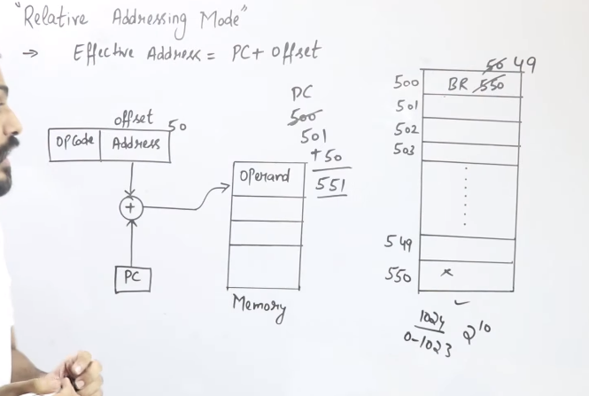 Adv – Direct AM ki tarah poora address ni dete bs offset dalna hota hai bs. Toh instruction ki size kum hojati hai.

Control instructions hai agr ki mtlb sequentially na jaa k Jump krna hai toh use this.

* 1. Base Register Addressing Mode – Program relocation me use krte hai. Limited programs hi aa skte hai MM k andar. Jb MM fill hojayega tb P1 nikaal lo ya wo Program jiska use ni hai usko bahar nikalo aur replace kr do kisi aur program se jo bahar tha.

Ab wo Program wps aaya tb usi location m nahi jayega. Ya kisi program ki location chnge krni hai usek liye we use this AM.

Base Reg Address le le Ex -100

100 se gya 104 tk thn 104 me the BR 60 toh ab effective address calculate hoga, EA = Base Reg Value +Displacement =

EA = 100+60 =160

Maan lo wps aaya value bahar jaa k toh if 404 p aaya toh 400+60=460 hoga ab (ab 400 is base address).

Lelin agr BR 160 likhte toh 104 pr hota toh wahn se direct jump krta 160 p

60 is displacement and 160 is absolute address

Aur agar execute ho kr bahaar jata and wps aata tb 404 m aaya agr toh wahan se 160 pr jump krne ka instruction hoga pr tb tk 160 pr koi aur hoga toh galat address hai isliye,

Displacement use krte hai taaki aage jaaye base Reg address k instead of absolute address jo ki peeche jump krwa skta hai.

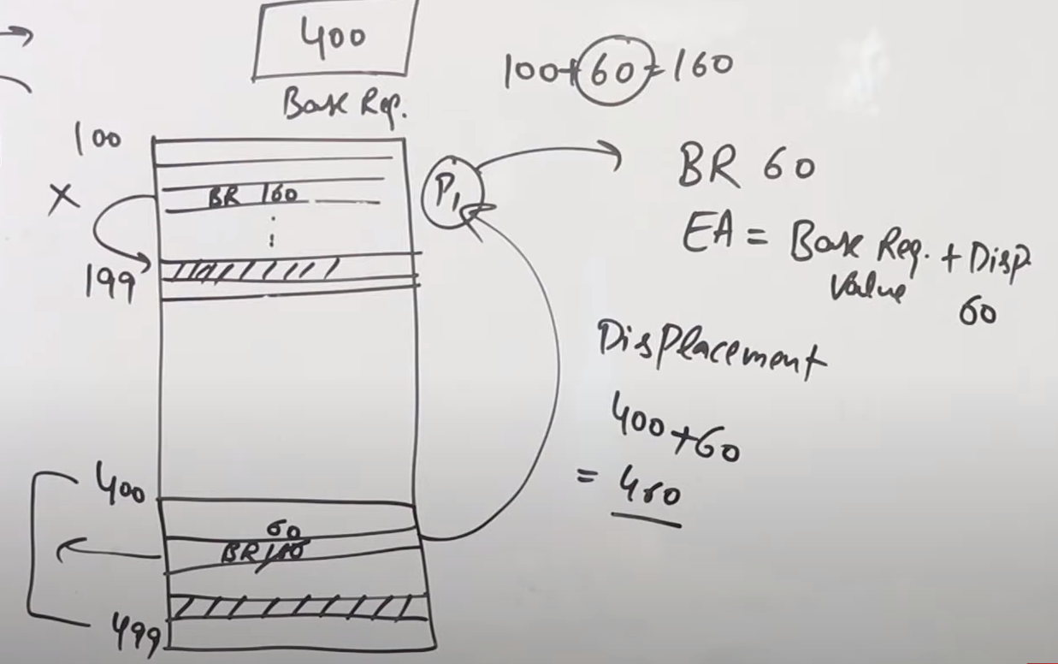

* 1. Indexed Addressing Mode – Array k values ko access krna hai toh use krte. Address field me base address hai Array ka

Multiple Regs use hote ism, ek Reg ko Index Reg bna do.

EA = Base address + Index Reg = 100 + 4 = 104.

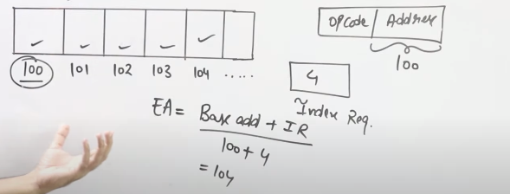

Ab jo bhi address access krna hai toh instruction (Opcode and Operand) jo hai wo mt chnge kro bs Index Reg ki value chnge kr do bs. (100+6=106).

Memory Hierarchy –

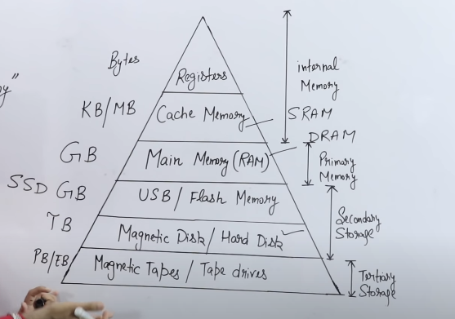Size Badhega

Access Time Badhega

Speed Badhega

Frequency (Kaun zyada baar use hoga)

**Independent vs Hierarchical Memory Organisation –**

2-Level Memory Organisation –

**Independent –** CPU, L1 and L2 se Parallel connection me hai.

L1 speed is more and Access Time is less.

Agr data jo chahiye L1 m hi mil gya toh Hit kehte hai usko, Agr ni mila which is called FAULT toh L2 me mil hi jayega.

L1 me milne se Fast milega.

Average Access Time – Tavg = H1T1 + (1-H1)T2 (H is the hit ratio and

T1 = access Time for L1 and T2 for L2)

Hum Parellel khoj re hai L1 and L2 me .

**Hit ratio di hogi – kitna chance hai hit hone ka.**

**Hierarchical –** CPU=>L1=>L2

Tavg = H1T1 + (1-H1)(T1 + T2)

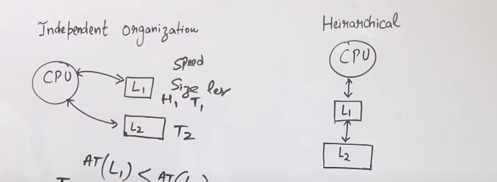

**3-Level Memory Organisation –**

**Independent –**

CPU Parallel m connected hai L1, L2 and L3 se

Tavg = H1T1 + (1-H1)H2T2 +(1-H1)(1-H2) T3

H3 likhne ki zaroorat ni kyunki agar shuru k 2 levels m ni mila toh H3 m toh 100% milega.

**Hierarchical -**

Tavg = H1T1 + (1-H1)H2(T1+T2) + (1-H1)(1-H2)(T1+T2+T3)

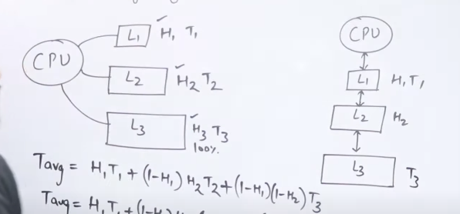

**Agr 2 levels diye hai aur MM bhi diya hai toh 3 levels hojayenge in total. Use Independent method mostly**

**Cache Mapping** – CPU is directly connected to cache and then it is connected to RAM and SM. We use memory hierarchy to increase speed and avoid high cost. Cache ko divide krte hai lines me, Agr RAM k kisi block ko utha k cache m laa re ho toh wo kidhr aayega nd CPU se kaise reference krega ya call krega wo decide hota hai with cache mapping.

Types – **Direct Mapping, Fully Associative, K-way Set Associative**.

**Direct Mapping –**

128 words hai total, harr block m 4 words hai toh toh total 32 blocks.

16 words, every line has 4 words tih total 4 lines.

As Cache ka size hai 16 words ka toh kaun se 16 words ayenge from MM to Cache.

Formula used = k mod n (k= Block no, n= no. of lines)

0 mod 4 = 0

Block number 0 mod number of lines

So B0(w1,w2,w3,w4) will be at line 0.

B1 = 1mod4 = 1 = line1

B4 = 4mod4 = 0 = line0

Agr ek block hai toh baaki blocks us particular line m ni ho skte coz 4 hi words aaskte ek line m.

**CPU access kaise krega**. – Referencing k liye Address ki zaroorat hoti hai,

MM me Physical address generate hota hai, ab 128 words hai toh inko represent kr skte hum 2^7 bits se and block size hai 4 bcoz 4words hai which is 2^2 so block numbers kitne hai 2^5

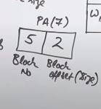Example – 00010 10

2nd block and 2nd word uthana hai.  
Cache me address kaise generate hota hai. Block offset/size is 2^2 only, Line no. k liye 2 bits hain coz size 4 hai line ka, ek line m itne saare block m se koi bhi hoskta hai ek time p, B0,B4,B8,B12. Toh kaun sa block hai wo batayega ye 2^3 bits ka hoga.

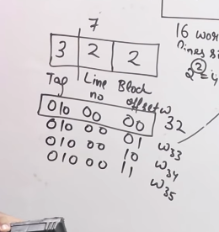 As it is word 32 so B8 is inside the line 0

Agr CPU jo Block khoj rah ai wo mil gya hai usko cache m hi toh usko kehte hai Cache Hit and jb ni krta hai tb Cache Miss.

**Line size = Block size**

**We can improve Cache performance using higher cache block size, and higher associativity, reduce miss rate, reduce miss penalty, and reduce the time to hit in the cache.**

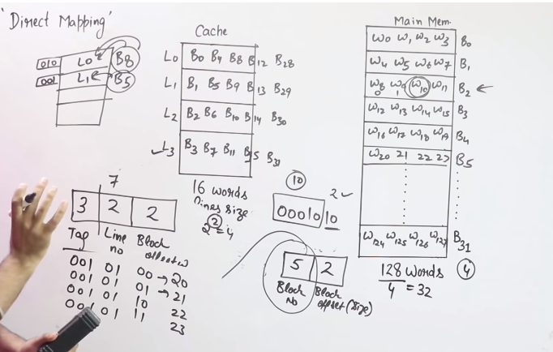

Adv of Direct Mapping – Searching is easy coz ek hi comparison krna hai.

Dis – We use k mod 4, mtlb ki 5mod4 =1 and 9mod4 =1, already B5 tha L1 me lekin ab B9 aana chahta hai toh B5 replace krna hoga. Toh space available hone k baad bhi usi line m ja ra hai. Isko Conflict Miss kehte hai.

**Fully Associative** – Direct Mapping me b0 – line 0 m hi aayega but idhr Koi bhi block kisi bhi line m aa skta hai.

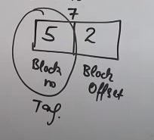 Block ka size 2bit, as koi bhi block aaskta hai toh ism alag s line number ni hoga so Tag size will be 5bit.

L0 me B0-B31 koi bhi aaskta hai.

Tag Block Offset

5 2

00100 00 = 16 (B4 will be in L0)

00100 01

00100 10

00100 11

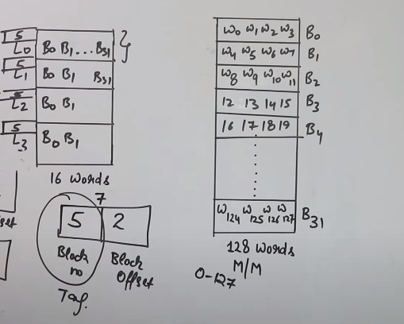128 words hai isko represent krte will 7 bits= 2^7.

4 words ko 2=2^7

32 blocks ko 5=2^5

**k-way Set Associative** – It’s a blend of Direct and Fully Associative

K ki value di hogi, Here take 2-way Set

Total number of sets=No of lines/K =4/2=2

Use Direct mapping First

K mod n (here n = no. of set)

2 set hai each includes 22 lines toh koi block Ex- B0 = 0mod2 =0

S0 m L0 ya L1 me kahin aaskta B0.

B1 = 1mod4 =1 S0

Even will be at B0

Odd will be at B1

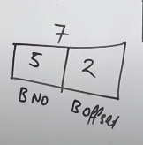 Physical Address

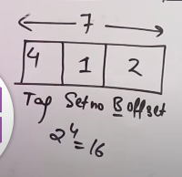 Cache Address

Tag me 16 words which means 4 se represent krte=2^4

Set 2 hi hai toh represent kr skte with 1

Block offset 2

0010 0 00

Tag Set no. Block offsets

Set 0 m jaao, then Tag 0010 ko match kro Tag value se in S0 Toh Line 1 me aayega, 00 mtlb B0 aayega L1 me.

Locality of Reference - Processer uss jisko recently access kiya hai usko wps reference krne k chances zyada hai.

* 1. Spatial Locality – Related to Space – If w0 access hua hai toh w1 ko access hone ka chance bohot zyada hai toh Poora Block hi laa lete hai from MM to Cache. Close Proximity waale Words.

Jitne Zyada words honge block m utna zyada Cache Hit hoga.

Toh Block size affects krta Spatial Locality.

* 1. Temporal Locality – Related to Time. – w0,w1,w2 hai already block m and w3 aata hai toh w2 ko mt hatao kyunkiisk wps aane k chances zyada hai tb w0 ko hata lo kyunki wo pehle aaya hai.  
     LRU – Least recently used – w0 k wps aane k chances kum hai wrt to w2 toh w0 nikaal lo.

**Cache Replacement Policies** – Cache k andar k data ko replace krna hai aur aisa krna hai ki Hit zyada ho. Isko Direct k andar ni kr skte kyunki B1 jo hai L1 m hi jayega s we use CRP in Fully or Set Associative.

* 1. FIFO
  2. LRU – Least Recently used.
  3. MRU – Most Recently Used.
  4. RANDOM

4GB = GB=2^30 and 4= 2^2, So physical address or representation

=2^2*2^30 = 2^32

Byte = 2^10

MB = 2^20

GB = 2^30

**Pipelining** – Hardware ko stages m divide kiya gya hai taaki cost efficient ho aur fast ho kaam.

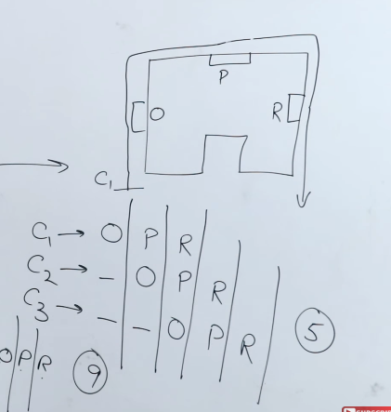 Ex – Ek car jb Pehla kisi Process ka stage1/Segment 1 kr ra hai toh dusra car wait kr ra and jb CAR1 gya 2nd stage p jayega uss process k tb CAR2 Use krega ab Stage1 and so on. Normally Process End hone ka wait krna pdta tha Car2 ko But due to pipelining Process ko stages m divide kr diya gya hai jiski wajah se ek process ko bohot saare Cars use kr skte ek saath at different stages.

Pipelining is the process of arrangement of hardware elements of CPU such that its overall performance increased.

Simultaneous execution of more than one instruction takes place in pipelined Processor. Multiple instructions are overlapped in execution.

Stages k beech m Interface registers hai to keep Intermediate results,

S1 ka Output is S2 ka input toh beech m store krne k liye Interface Reg use krte.

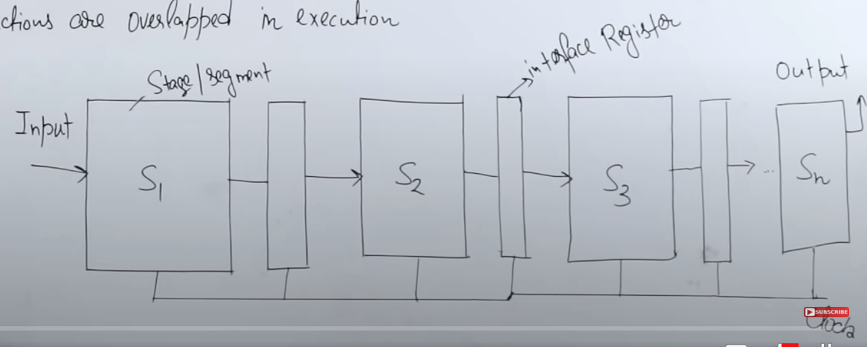

All Stages are connected with clock as jaise hi ek clock cycle apply hoga saare instructions execute honge.

Kisi instruction ko execute hone k liye in a 5 stage Pipelining, 5 stages se ho k guzarna hota hai. Ab ek clock cycle (CC)  lgti hai ek stage ko khtm hone m toh 1 process with 5 stage will take 5CC. And is program m hai 8 instruction so it will take 50 clock cycle. Uniform Clock cycle hai idhr.

F1 aya S1 me then S2 gya F2 tb tk F1 use krega and so on.

Five Stages –

* 1. Instruction Fetch
  2. Instruction Decode
  3. Execute
  4. Memory
  5. Write Back (Memory m wps dalna)

N instructions hain and K stages hain

1st  ko poora hone m K time lagega. And Baaki ko khtm hone m n-1.

K+n-1

5 stages and 8 instruction = 5+(8-7) =12stages.

If 1 clock cycle is of 1ms then 12*1ms =12

Speedup – None Pipelined/pipelined => 40cc/12cc=3

Non-Pipelined = 8Insturctions*5Stages=40cc

Efficiency = No. of blocks used/Total Blocks = 40/60=2/3

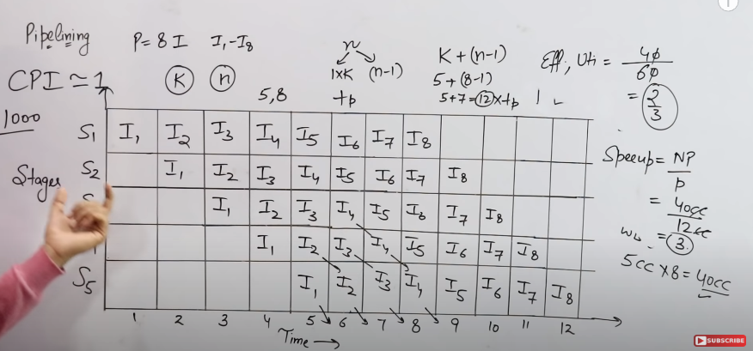

**Hazards or Dependencies in Pipelining** – Problems in Pipelining, Clock Per Instruction should be 1, to achieve this is very hard, delays aate hain.

This dependency arises due to the resource conflict in the pipeline. A resource conflict is a situation when more than one instruction tries to access the same resource in the same cycle.

Types -

* 1. Data Hazard – Read After Write, Write after Read, Write after Write.
  2. Structural Hazard.
  3. Control Hazard.

**Structural Hazard** – Multiple instructions are accessing different Resources like MM, Reg, Cache.

Same Resource Memory ko use kr rahe hai jb Multiple Instructions, Conflict will be there coz only one will be executed. Solve krne ka tareeka hota hai ki Resource duplicate kr do, Resources ko bhi Pipeline m convert kr do, Resource Renaming kr do.

**Renaming :** According to renaming, we divide the memory into two independent modules used to store the instruction and data separately called Code memory(CM) and Data memory(DM) respectively. CM will contain all the instructions and DM will contain all the operands that are required for the instructions.

**Stall : A stall is a cycle in the pipeline without new input.**

**Branch penalty : The number of stalls introduced during the branch operations in the pipelined processor is known as branch penalty**

**Control or Branch Hazard** – All the instruction who change the program counter leads to control hazard. Normally sequentially chlta hai PC, But jb Branch aajaye tb Wahan se kisi durr address pr jump krta hai.

Instruction1 chla aur Execute hua

I2 chla lekin WB k time Ek case tha Bnez R1,2000 mtlb Branch not equal to 0 hai toh ishr se jump krega siddha 2000 me,

Lekin WB pahucha I2 6CC me tb tk I3 MM Stage p tha I4 EX stage m tha aur I5 ID stage me,

Jump krne se I3-I5 waste hogye.

This Degrades Performance, The Worst hazard.

To avoid this Just use a **Stalls** which means agr ID ya EX stage m pta chl gya ki branch aane wala hai toh Sidha jump hoga 2000 pe nd I3 Ruk jayega.

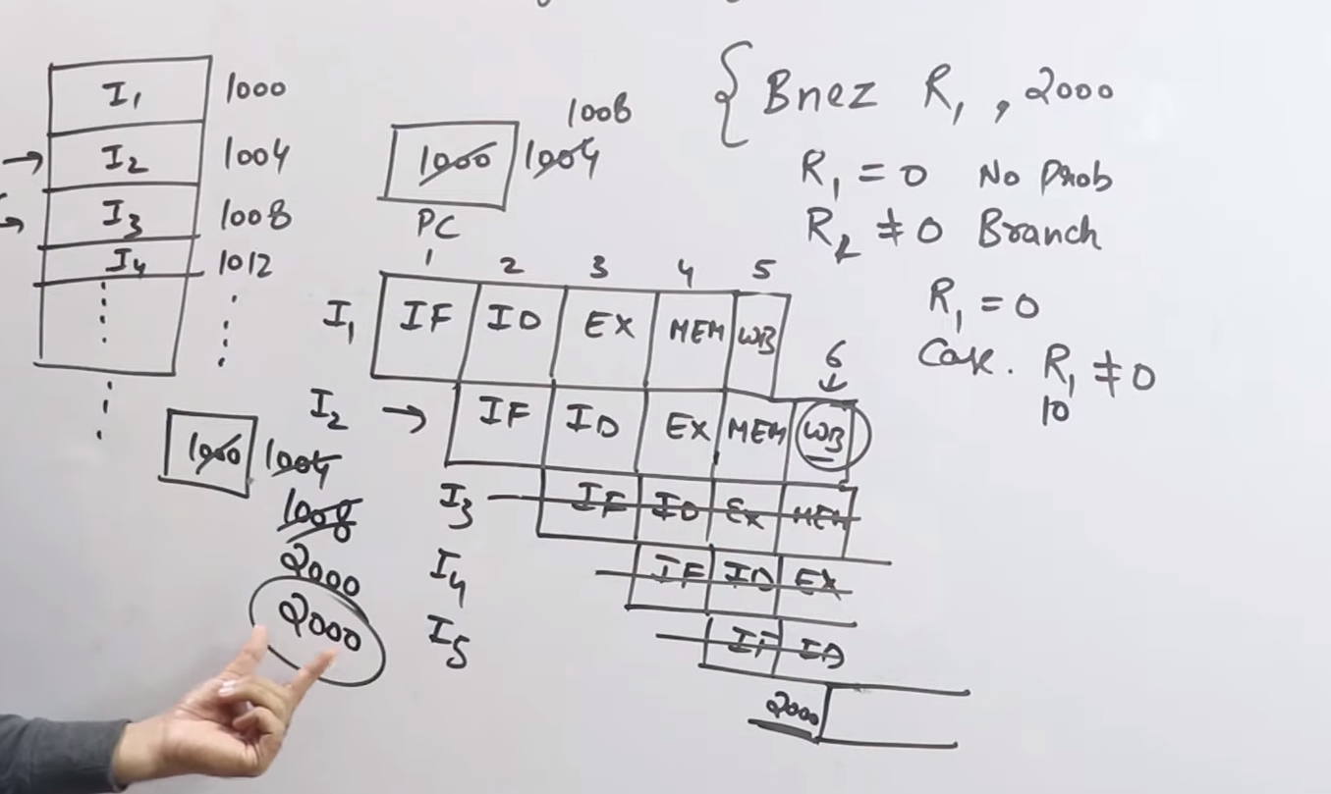

Branch Prediction is the method through which stalls due to control dependency or hazard can be eliminated.

**RAW** –

I1 R3 = R1+R2

I2 R5 = R4+R3

I1 abhi execute hua ni hai aur I2 R3 ki value use kr rah hai, R3 ki Poorai value use hogi this will create problems. Stall Create kr do taaki I2 start ho after I1 update hochuka hai.

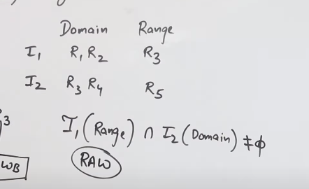To Find If there is RAW

Agr Range I1 ka I2 ka Domain m hai toh RAW hai.

Operand Forwarding/Short Circuiting to resolve RAW - Stall Create kr dne hai Taaki WB hone k baad hi I1 se jo value nikal ri wo I2 ko mile, Tb tk I2 ki delay kr do.

Iss se badhiya hai ki R3 ko read kr ko Pehle hi daal de I2 me taaki wait na krna pde

**WAR** –

I1 R1=R2+R3

I2 R2=R4+R5

Normally I1 pehle execute hota hai thn I2 but agr I1 delay hua tb I2 k execute hone pr R2 ki value jo thi chnge hojayegi jiski wajah se R1 ki value bhi chnge hojayegi.

Ism pehle read bs ho rah ai then Write ho rahi hai I1 and I2.

Normal – Hazard

R1=10+20 R1=70+20

R2=30+40 R2=30+40

I2 pehle Execute ho k R2 ki value chnge kr diya I1 m.

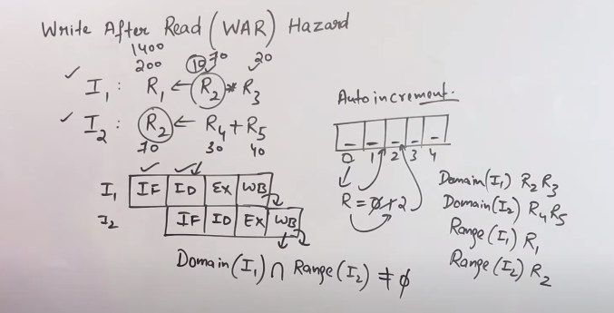

**WAW** –

I1 R3 = R1*R2

I2 R3 = R4+R5

Normally I1 execute hota hai, but agr Delay k karan I2 pehle hogyi toh I2 execute hone k baad galat value ajayegi R3 m.

Ism dono Write ho re I1 and I2

Agr 2 system parallel kaam kr re but data and Reg same use ho re tb hi hota hai ue HAZARD.

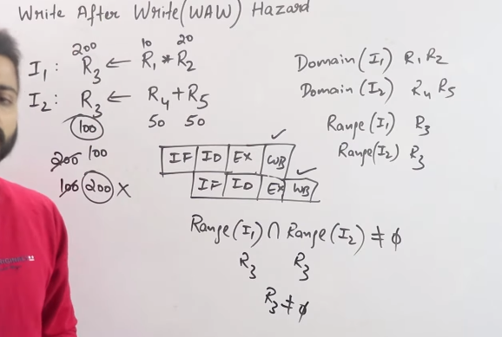

To minimize data dependency -Operand forwarding, we use the interface registers present between the stages to hold intermediate output so that dependent instruction can access new value from the interface register directly.

Register Renaming –

I1 R3 = R1*R2

I2 R3 = R4+R5

Temporary Reg T1 m store kr do I1 and aur T1 ko rename kr do R3 se and ab sequentially Access kr skte.

I1 R1=R2+R3

I2 R2=R4+R5

R2 ki value ko T1 m store kr and Dusri R2 ki value ko T2 me.

WAR and WAW ko resolve krne k liye use krte.

I/O Device –

The method that is used to transfer information between internal storage and external I/O devices is known as I/O interface. There exists special hardware components between CPU and peripherals to supervise and synchronize all the input and output transfers that are called interface units.

Data transfer between CPU and the I/O devices may be done in different modes.

1. Programmed I/O.
2. Interrupt- initiated I/O.
3. Direct memory access (DMA).

Interrupt –

Type – Hardware interrupts, software interrupts, vectored Interrupts, non vectored interrupts, maskable interrupts, non maskable interrupts, external interrupts, internal interrupts, synchronous interrupts and asynchronous interrupts

**Direct Memory Access**: The data transfer between a fast storage media such as magnetic disk and memory unit is limited by the speed of the CPU. Thus we can allow the peripherals directly communicate with each other using the memory buses, removing the intervention of the CPU. This type of data transfer technique is known as DMA

When an Interrupt occurs –

* 1. The processor finishes the execution of current instruction
  2. The processor pushes status of L onto control stack (PC ki jo value thi next usko store krega)
  3. The processor loads the new Program Counter value based on interrupt (Kya krna hai wo dekhega)
  4. The processor executes the interrupt service routine
  5. The pressure pops the process status of L from control stack

Number System -